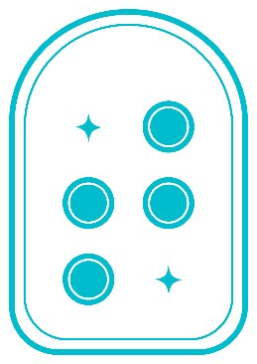

**Taptilo**

**User Guide**

Taptilo 2.0+ (ENG)

Last updated: June 2020

© OHFA Tech, Inc.

**Contact**

Email: [support@taptilo.com](mailto:support@taptilo.com)

Online: [www.taptilo.com/support](http://www.taptilo.com/support)

# About this guide

* Taptilo®, all hardware, software and applications associated with Taptilo, the Taptilo logo are trademarks of OHFA Tech Inc., registered in the U.S. and internationally.
* This user guide and product are protected by copyright law.
* This user guide is based on the status quo and may include technical and editorial error or omissions.
* The images used in this user guide may look different from the actual product. The product and user guide are subject to modification without prior notice to improve accuracy and performance.

# Important safety & handling instructions

* Follow all warnings, cautions, and instructions marked on the product.
* Carefully read the instructions described in this user guide prior to using Taptilo.
* Keep away from heat sources or radiator. Exposure to high heat may lead to weaken magnetic properties and possibly cause a fire.
* Do not handle the device or the plug with wet hands as it may cause electric shock.
* Do not place sharp metal objects near the device, as the magnet may attract the objects.
* Only use charging adaptors provided with the product. Charging with a non-designated charger will void your warranty and possibly cause a fire.
* Do not disassemble or alter any part of the device, including the serial number label.
* Don’t attempt to replace the battery yourself.
* Do not use or store below 0°C (32°F) or above 50°C (122°F), as it may cause malfunctions.
* Do not place device near liquids to prevent spillage. In case of accidental spillage, turn the device off, flip upside down and store in a dry area and contact the support center immediately. (In case the individual blocks are wet, they may be reused after completely drying, but this may cause defect.)
* Do not place under heavy objects. Avoid unusual stress (i.e. dropping from heights) to the device.
* Avoid charging the device during a thunderstorm.
* Avoid pressurizing the braille display when it is refreshing as it may limit proper movement of the cells. Limited performance or malfunctions caused by such actions will not be accepted as a valid claim for warranty returns.

# Table of Contents

1. Overview of Taptilo 5

1.1 Unpacking 5

1.2 Physical Description 5

1.3 Specifications 8

2. Setting Up and Getting Started 9

2.1 Charging the Battery 9

2.2 Powering On/Off 10

2.3 Choosing a Study Mode 10

2.4 Using the Braille Blocks (Writing Styles) 11

2.4.1 Common (Perkins Style) 11

2.4.2 Slate & Stylus 12

2.5 Pairing with the App 13

2.5.1 Downloading the Taptilo+ app 13

2.5.2 Connecting with the device 14

2.5.3 Managing connection settings 14

2.6 Button Navigation 15

3. Self-Study Mode 16

3.1 Getting started 16

3.2 Activities 17

3.2.1 Read 17

3.2.2 Trace & Write 17

3.2.3 Dictation 17

3.2.4 Write 18

3.2.5 Game 18

3.3 Choosing Braille Settings 19

3.4 Device settings 20

3.4.1 Program 20

3.4.2 Voice 20

3.4.3 Writing Style 20

4. Teaching Mode 21

4.1 App Overview 21

4.1.1 Main screen 21

4.1.2 Word screen 22

4.2 Topics 23

4.2.1 Alphabet 23

4.2.2 Numbers 23

4.2.3 Words (Levels 1-5) 23

4.3 Activities 23

4.3.1 Trace & Write 23

4.3.2 Read 24

4.3.3 Listen & Write 24

4.4 Practice Settings Tab 24

4.4.1 Shuffle list 25

4.4.2 Auto continue 25

4.4.3 Auto play voice 25

4.4.5 Vibrate for wrong answer 25

4.4.6 Slate & Stylus 25

4.5 Favorites 26

4.5.1 Adding or removing a favorite word 26

4.5.2 Managing Favorites List 26

4.6 My Word List 27

4.6.1 Adding a new list 27

4.6.4 Adding words 27

4.6.5 Deleting words 28

4.6.2 Editing list name 28

4.6.3 Deleting list 28

4.7 Managing Application Settings 28

4.7.1 Bluetooth connection 28

4.7.2 Language settings 29

4.7.3 Practice Reminder 30

4.7.4 Send Feedback 31

4.7.5 About 31

5. Taptilo Music (Beta) 31

5.1 Using Taptilo Music 31

5.1.1 Starting Taptilo Music 31

5.1.2 Ending Taptilo Music 31

5.2 Music: Activities 32

5.2.1 Play a song 32

5.2.2 Solfege 32

5.2.3 Compose 32

# 1. Overview of Taptilo

## 1.1 Unpacking

The package includes the following items:

* Taptilo device (includes 9 braille blocks)
* Extra braille block
* Adaptor & micro USB cable
* Mini pouch
* Taptilo case + shoulder strap
* Quick Start Guide (1 print, 1 braille)

## 1.2 Physical Description

Taptilo has a rounded rectangular shape, almost circular around the edges. It is about 17 inches long, 5.4 inches wide, 2.2 inches in height, and it weighs about 3 pounds.

Taptilo’s top surface includes a row of nine braille blocks on the upper half, a corresponding braille display on the lower half, and three buttons to the right. The long side with the braille display faces the user.

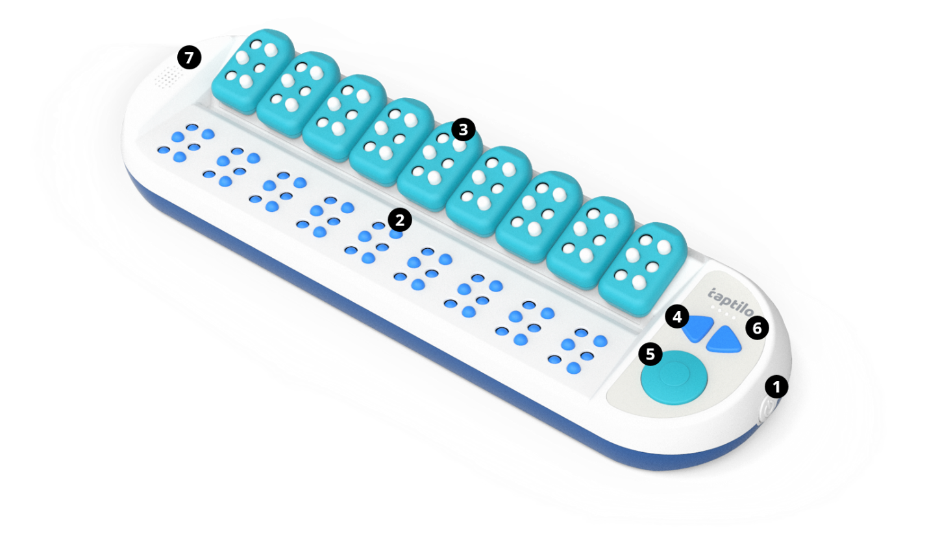

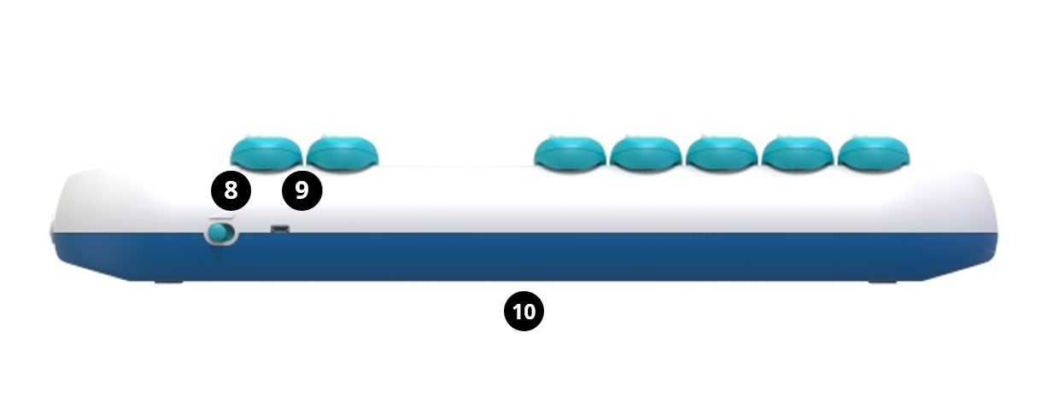

**1) Power button (On/Off)**

The power button is located on the right edge and has a circular shape. For more information, see 2.2 Powering On/Off.

**2) Braille display (for reading)**

The braille display contains nine braille cells containing six large-sized pins, which are approximately five times larger than the standard braille.

**3) Braille blocks (for writing)**

There are nine oversized braille blocks in total, each of them removable and magnetic. A braille block is a vertical rectangular shape with a circular edge on the top and rounded angles on the bottom. Each block represents one braille cell and has six dots, arranged in two columns of three dots. For more information, see 2.4 Using the Braille Blocks.

**4) Arrow buttons (left & right)**

The arrow buttons are located on the right side of the device, next to the braille blocks. The arrow buttons are used to move to the next or previous option. For more information on button navigation, see 2.6 Button Navigation.

**5) Circle button**

The circle button is located on the right side of the device, below the arrow buttons. The circle button is used to select an option or submit an input (check the answer). For more information on button navigation, see 2.6 Button Navigation.

**6) LED battery indicator**

Located above the arrow buttons, there are four LED lights that indicate remaining battery life and charging status. For more information, see 2.1 Charging the Battery.

**7) Speaker & headphone jack**

The built-in speaker is located on the left side of the device, next to the braille display. Below the speaker on the left edge is a standard audio jack which is compatible with headphones or other audio devices.

**8)** **Volume controller**

The volume controller is a toggle switch located on the right side of the upper edge. You can adjust the volume in 3 levels. When you push to the left (assuming the braille display is facing the user), the volume will increase.

**9) Charging port (micro-USB)**

The charging port is located on the upper edge to the right of the volume controller.

**10) Serial number label**

The serial number label is located on the bottom of the device. You need the serial number when you connect the device with the application (See 2.5 Pairing with the app)

## 1.3 Specifications

1. Product: Taptilo V2.0+
2. Model: TEDU-W500USA
3. Color: Blue
4. Language: English (USA)
5. Power
   * Main voltage: +5.0V
   * Battery: Li-ion 2,600mAh (3.7V)
   * Adaptor: input 100V~240V (0.5A) / output 5.0V (2.0A)
   * Charging time: 5 hours
   * Running time: 15 hours
6. Wireless
   * Bluetooth 4.2
7. Temperature
   * In operation: 15°C ~ 35°C
   * On hold: -10°C ~ 60°C
8. Size
   * Main Body: 437 x 137 x 55.6 (mm)
   * Block: 33.6 x 56.2 x 16.8 (mm)
9. Weight
   * Main Body: 3lb / 1.4kg
   * Block: 0.04lb / 20g

# 2. Setting Up and Getting Started

## 2.1 Charging the Battery

**For the best experience, we recommend fully charging the device before the first use.**

Image showing location of charging port



1. Connect the charger to the charging port on the top end of Taptilo device, next to the volume controller.
2. When charging, all four lights on the LED indicator will blink. When the battery is fully charged, all four lights will light up.
3. When not charging (and the device is on), the LED lights will display how much battery is left. When the leftmost LED is blinking alone, the device needs charging.
4. To check battery status via audio when the device is on, press the circle button and right arrow key together for two seconds.

**Caution:** Using any other charging appliances may affect the performance of the device and possibly cause a fire.

**TIP:**

* Five hours of charging will provide up to 15 hours of usage. When the battery dies during use, please charge the device for a minimum of one hour before using it again.
* When the device is not being used, an alarm (light bell sound will ring twice) will sound every 10 minutes to remind you to power off.
* When the device is turned off due to low battery level, it will restart automatically when you start charging the device.

## 2.2 Powering On/Off

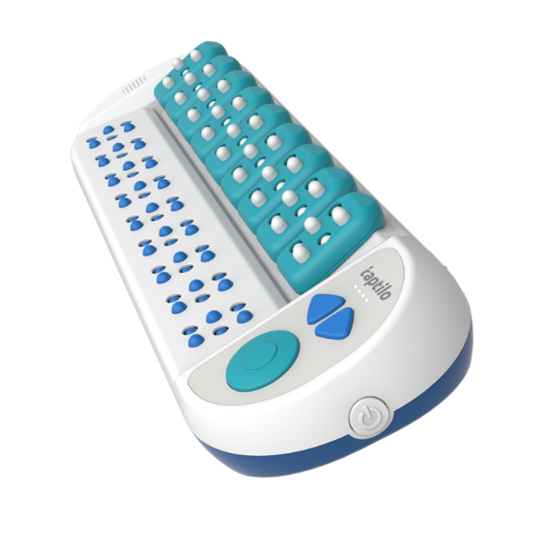

To Power ON

* Press the power button once until it is slightly pushed in. Wait a few seconds as the LED lights start blinking.
* With a sound effect, all the braille cells will move up. Follow the audio instructions to continue.

To Power OFF

* Press the power button once until it is slightly pushed out.
* With a sound effect, all the braille cells will go down, and you will hear the audio, “See you again later.” The LED lights will turn off one by one.

## 2.3 Choosing a Study Mode

Taptilo has two study modes: Self-Study Mode and Teaching Mode.

In Self-Study Mode, t he device is used standalone using the built-in programs and audio guidance. See 3. Self-Study Mode.

In Teaching Mode, the device is used with the app, and the user has access to the various content and features available on the app. See 4. Teaching Mode.

## 2.4 Using the Braille Blocks (Writing Styles)

There are two different ways to write braille using the Taptilo braille blocks: Common (Perkins Style) and Slate & Stylus. The default setting is Common.

For instructions on changing the braille writing style,

* From the device, see 3.4 Device Settings
* From the app, see 4.4 Practice Settings.

### 2.4.1 Common (Perkins Style)

The common writing style allows the user to write in the same order as in reading (left to right). With this method, the user can get familiarized with the Perkins skyle finger location (Index, middle and ring finger of left hand on dots 1, 2, 3 and index, middle and ring finger of the right hand on dots 4, 5, 6).

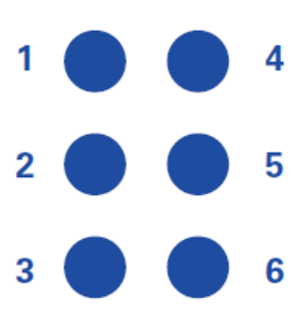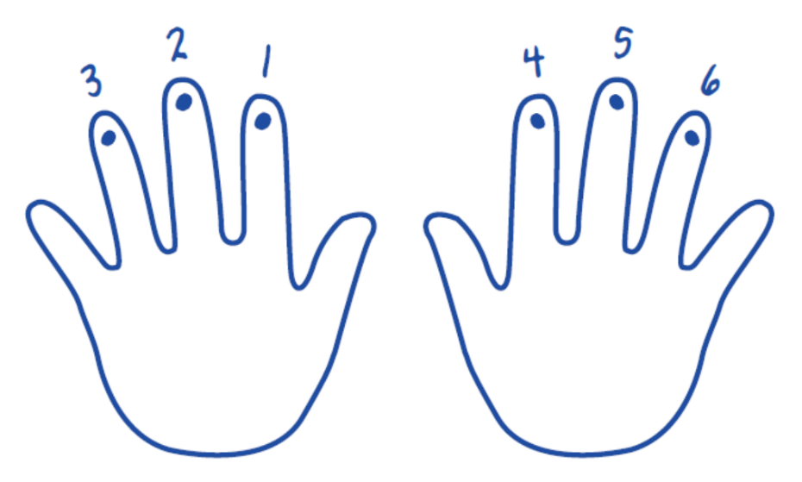

**How to use**

1. Hold a block upright with both hands, the front side facing the user. Start with all the dots pushed down – this is an empty cell.
2. Place your thumbs on the front, and place your index, middle, and ring fingers behind each of the six dots. The index, middle and ring finger of your left hand will be on dots 1, 2, 3. Your index, middle and ring finger of your right hand will be on dots 4, 5, 6.
3. With each finger, push the dots upward. For instance, to create ‘a’, push dot 1 with your left hand’s index finger.
4. To check what you wrote, place the blocks on Taptilo from left to right. All dots of empty cells should be pushed down. Press the circle button to check the answer.

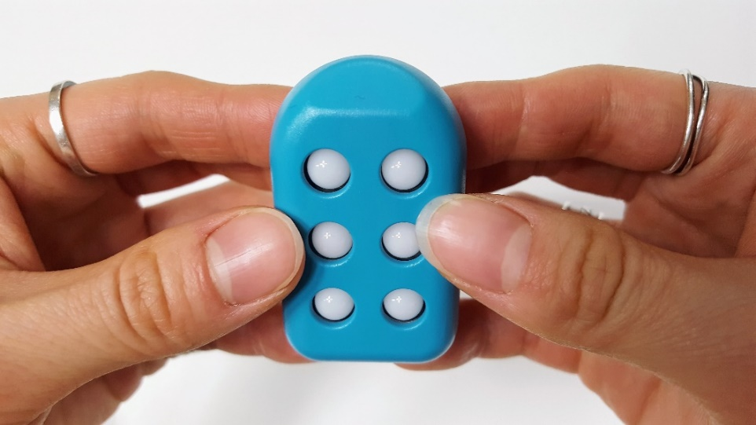

**Tip:**

It’s important to tell the front and back of the block when using it with Taptilo. When you place the block on the wrong side, you won’t feel the same magnetic “click” that you feel when you place it correctly, and Taptilo won’t be able to recognize the pattern. Another way to tell is by feeling the top of the block - the front is flat while the back is sticking out.

### 2.4.2 Slate & Stylus

The slate & stylus writing style allows the user to write in the reverse order as in reading (right to left). With this method, the user can get familiarized with the slate and stylus writing (dots 1, 2, 3 from the top on the right column and dots 4, 5, 6 from the top on the left column – see image below).

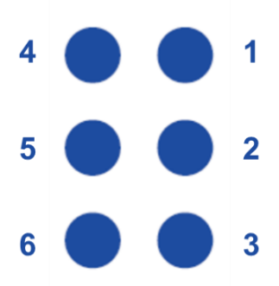

**With one block**

To see how this works, let’s take a braille block. First, push all the dots up – this is an empty cell. Hold the block upright in one hand, the front side facing you. Then, using the index finger of your other hand, push each dot down.

**TIP:** To check whether you have written correctly, flip the block over and scan the pattern – this should match the braille display below. This is similar to the way one would flip the paper over after writing with a slate and a stylus pen.

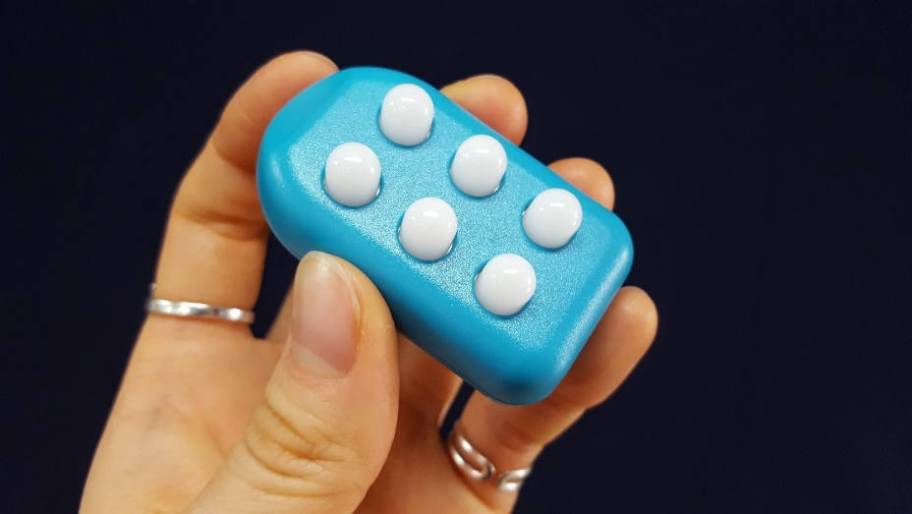

**With multiple blocks**

First, you need to make all cells “empty” by pushing the dots up on all the blocks and placing them back on the base. Then, starting from the right-hand side, use your index finger to push down the dots. If you’ve made a mistake and want to rewrite, just pick the block up and make an empty cell.

## 2.5 Pairing with the App

### 2.5.1 Downloading the Taptilo+ app

1. Scan the QR code below or search for ‘Taptilo+’ in the Apple App store or Google Play Store to download the app.

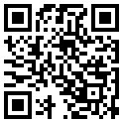

### 2.5.2 Connecting with the device

1. Turn on Taptilo and wait until you hear the audio guidance.
2. Open the Taptilo+ app on your phone and make sure Bluetooth is turned on.
3. Select the block image or “Tap to connect your device.” A connection pop-up will appear, or the app will automatically reconnect with the previous device if it is within Bluetooth range.
4. From the pop-up, select the serial number of your device (The serial number label is located near the center of the bottom of the device). If the serial number does not appear on the pop-up, refresh list by selecting “search again.”
5. Once the device is paired, you will hear “application connected” and you can start using the app features.

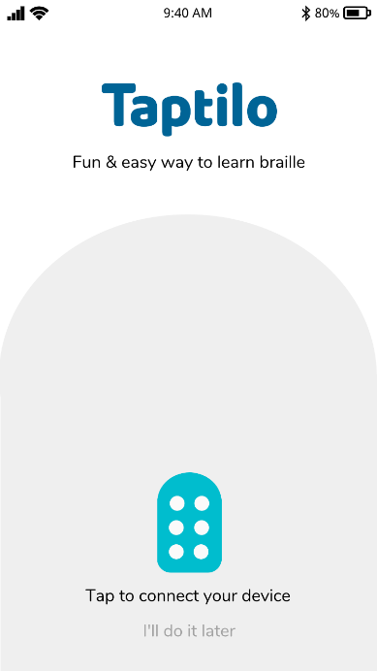 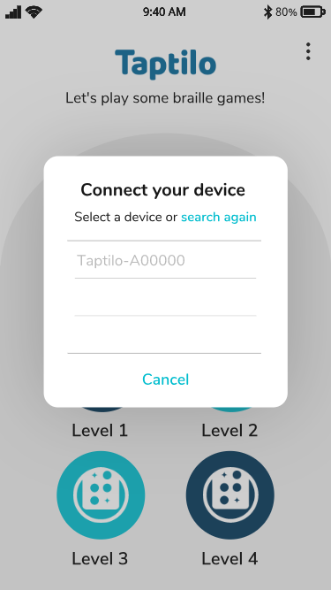

### 2.5.3 Managing connection settings

From the app main menu, select the Options tab on the upper right corner, then select Settings > Connect your device. You can connect or disconnect to your device here.

For more information, see 4.7.1 Bluetooth connection.

## 2.6 Button Navigation

There are **three** buttons on the panel on the right side of the device: Left arrow, right arrow and a circle button. There are **two** ways to press each button: Short press, long press (press and hold for 2 seconds)



|  |  |  |
| --- | --- | --- |
|  | **Basic** | **Music** |
| Right arrow (short press) | Next word or option | Next section |
| Left arrow (short press) | Previous word or option | Previous section |
| Circle (short press) | Submit/Select | Play/Select |
| Right arrow (long press) | Hear spelling guide | Move to the next activity |
| Left arrow (long press) | Repeat pronunciation | Move to the previous activity |
| Circle (long press) | Move to the previous menu | Play again |
| Left and right arrow (long press) | Change braille mode  (Uncontracted↔Contracted) | Skip to the last or first activity |
| Right arrow + Circle (long press) | Check battery status (audio) | |
| Left and right arrow + circle (long press) | Enter or exit device settings | |

# 3. Self-Study Mode

When using the device on its own without the application, you are using Self-Study Mode.

## 3.1 Getting started

1. Turn the device on. When you hear the audio instructions for Self-Study Mode, press the circle button.
2. Use the arrow buttons to scroll through the list of activities. You will hear the name of each option as you scroll through. When you are on the option you want to choose, press the circle button.
3. Audio instructions will be played for the selected activity. If you would like to skip the instructions, press the circle button.
4. Next, choose a category using the buttons.
5. To return to the previous menu or option, press the circle button for two seconds.

Self-Study Mode contains five braille learning activities: Read, Trace & Write, Dictation, Write and Game. Each activity includes the following categories:

1. **Read:** Numbers, alphabet, short words, long words
2. **Trace & Write:** Numbers, alphabet, short words, long words
3. **Dictation:** Numbers, alphabet, short words, long words
4. **Write:** Write your own word
5. **Game**: Short words, long words

For detailed instructions on each program, see 3.2 Activities.

Tips:

* **Recent action saved.** In Self-Study Mode, Taptilo will save the most recent activity and category used when the device is powered off. When the device is turned on, the user will be directed to where they left off. To start from the beginning, press the circle button for two seconds.
* **Skip audio instructions.** Press the circle button at the start of each activity to skip audio instructions.
* **Power-saving feature.** When the device isn’t being used, an alarm (light bell sound will ring twice) will sound every 10 minutes to remind you to power off.

## 3.2 Activities

### 3.2.1 Read

Read the letter or word shown in braille and listen to the word. Choose from numbers, alphabet, short words and long words.

1. Read the braille shown on the braille display and listen to the word.
2. If you want to hear the word again, press the left arrow button for two seconds. To hear the spelling, press the right arrow button for two seconds.
3. Press the circle button to move to the next word.

### 3.2.2 Trace & Write

Practice reading and writing in braille by using the blocks. Choose from numbers, alphabet, short words and long words.

1. Read the braille shown on the braille display and listen to the word.
2. If you want to hear the word again, press the left arrow button for two seconds. To hear the spelling, press the right arrow button for two seconds.
3. Use the blocks to create the same letters and place them in the right order.
4. Press the circle button to check the answer.
5. If you get it wrong, you can try again until you get the correct answer. When you get it right, it will automatically move to the next word.

### 3.2.3 Dictation

Listen to a word and write it down using the blocks. It’s a spelling bee in braille! Choose from numbers, alphabet, short words, long words.

1. Listen to a word or a letter. If you want to hear it again, press and hold the left arrow button. The right arrow button that plays the spelling does not work in Dictation.
2. Use the blocks to write the letters and place them in the correct order.
3. Press the circle button to check the answer.
4. If you get it wrong, you can try again until you get the correct answer. If you get three incorrect answers in a row, the answer will be shown on the braille display. Afterwards, you can check it and write the correct answer (as in Trace & Write) to move onto the next word.

### 3.2.4 Write

Write anything in braille and check what you wrote.

1. Use the blocks to write your own braille and place them in order.

2. Press the circle button to check what you wrote.

3. Taptilo will display what you wrote and read it aloud.

TIP: Try writing your name and have Taptilo read it out!

### 3.2.5 Game

There are two types of games according to which braille setting you are using: Uncontracted braille (normal mode) and contracted braille (UEB mode).

When using uncontracted braille (normal mode), you are playing Word Scramble.

When using contracted braille (UEB mode), you are playing Guess-the-Contraction.

For information on how to change the braille setting in Self-Study Mode, see 3.3 Choosing Braille Settings.

**Word Scramble (Uncontracted Braille)**

Unscramble the letters to match the right word.

1. Read the scrambled letters shown on the braille display. To hear the spelling, press and hold the right arrow button for two seconds. The left arrow button that reads the word does not work in Game.
2. Use the blocks to write the letters and rearrange them in the correct order.
3. Press the circle button to check the answer.
4. After three incorrect attempts, the answer will be shown on the braille display. Now you can trace the letters and write them using the blocks (as in Trace & Write).

**Guess-the-Contraction (Contracted Braille)**

Write the correct contraction for the word shown in uncontracted braille.

1. Read the word shown on the braille display in uncontracted braille. To hear the spelling, press the right arrow button for two seconds.
2. Use the blocks to write the correct contraction of the word.
3. Press the circle button to check the answer.
4. After three incorrect attempts, the answer will be shown on the braille display and read aloud. Now you can trace the letters and write them using the blocks (as in Trace & Write).

**Note**: When you change the default braille setting while using Game, the braille will NOT automatically change. In this case, press the right or left arrow button to apply the new setting.

## 3.3 Choosing Braille Settings



On Taptilo, you can easily switch from uncontracted braille to contracted braille, and vise versa.

When using Self-Study Mode, the default is uncontracted braille (“Normal mode”). Press and hold the left and right arrow button for two seconds until you hear the audio “Change to UEB mode” and the braille will show in contractions. (If it doesn’t change, try pressing the right arrow button once to move to the next word)

If you want to change back to uncontracted braille, press and hold the left and right arrow button again until you hear the audio “Change to normal mode.”

**Note:**

* If you change the braille mode, it stays until you change it again even if you move to another activity or restart the device.
* When the device is connected with the app (Teaching Mode), it will follow the app settings.
* If the word or content does not have a contracted form, the braille cells will not change.

## 3.4 Device settings

You may use device settings at any point in Self-Study Mode.

**How to use**

1. With the device on, press all three buttons (left, right arrow and circle button) at once for two seconds until you hear the audio, “device settings.” Make sure you press three buttons all at once.
2. Using the arrow and circle buttons, enter the menu you want to change and select the option.
3. Once you select an option, the device will restart itself to apply the new setting. Please wait until you hear the audio instructions to start using it again.

### 3.4.1 Program

Choose from English or Music (beta)

### 3.4.2 Voice

Select the voice of the audio guidance. Choose from Diana (default) or Anna (for younger users). When you select Anna, you can hear some sound effects for certain words (i.e. animal sounds)

### 3.4.3 Writing Style

Select a braille writing style. Choose from Common (Default) or Slate & Stylus.

For information on writing styles, see 2.4 Using the Braille Blocks.

# 4. Teaching Mode

In Teaching Mode, the Taptilo device is used with the app, and the user has access to the various content and customization options available on the app.

For instructions on pairing with the app, see 2.5 Pairing with the App.

## 4.1 App Overview

### 4.1.1 Main screen

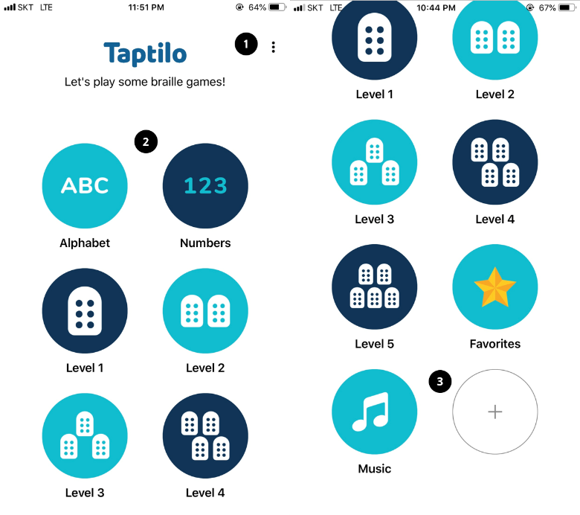

From the top:

1. **Options tab:** Located on the top right corner of the screen. Includes app settings and feedback.
2. **Content list:** Buttons arranged in two columns. Includes basic braille categories, favorites list, music program, add your own words
3. **Add new word list:** Located at the end of the content list. Tap on the button to create a new list.

### 4.1.2 Word screen

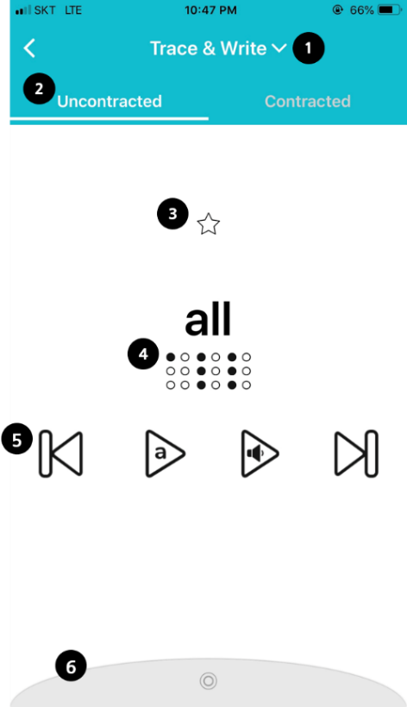

From the top:

1. **Activity:** Select from three options; Trace & Write, Read, Listen & Write. For description on each option, see 4.3 Activities.
2. **Uncontracted or Contracted Braille tab:** You can instantly change the braille output type of the word.
3. **Favorites:** Tap to add to your favorites list. Tap again to delete.
4. **Word & Braille image**: Current word shown in braille.
5. **Buttons** (From left to right)
   * Move to previous word or letter
   * Hear spelling of the word
   * Hear the word again
   * Move to the next word.
6. **Practice settings Tab:** Tap on the bar to open the settings menu. Tap again to close. For description on each option, see 4.4 Practice Settings.

## 4.2 Topics

### 4.2.1 Alphabet

The letters of the English alphabet are included.

### 4.2.2 Numbers

Basic numbers 0 to 20 are included.

### 4.2.3 Words (Levels 1-5)

1000+ basic literary words for elementary school literacy level are arranged in five levels according to its difficulty.

## 4.3 Activities

### 4.3.1 Trace & Write

Read the letters shown on the braille display and recreate using the blocks. Press the circle button to check the answer. For detailed instructions, see 3.2.2 Trace & Write.

The images below show the app screen when you have a wrong answer. Incorrect letters will be indicated in red (first image), and three red dots appear at the end of the word when you enter in more letters than needed (second image).

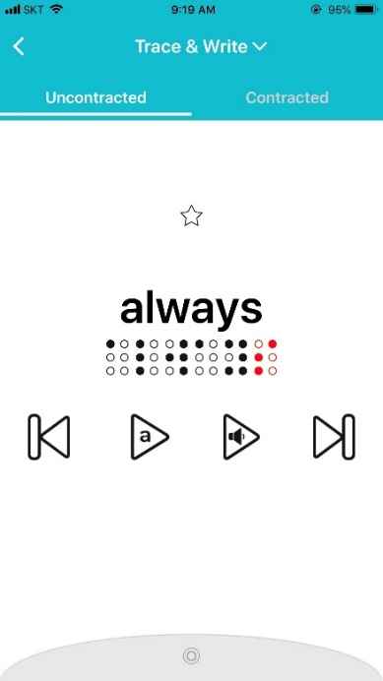 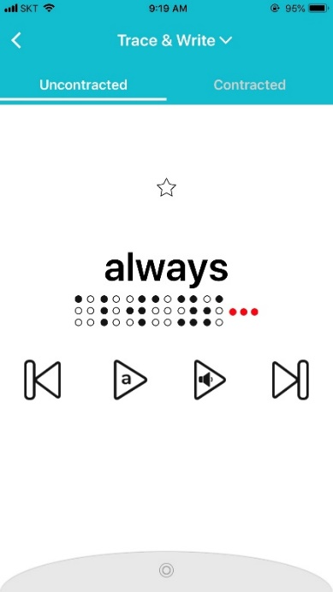

### 4.3.2 Read

Read the letters shown on the braille display and listen to the word. Press the circle button to move to the next word.

For detailed instructions, see 3.2.1 Read.

For instructions on using the buttons on the word screen, see 4.1.2 Word screen.

### 4.3.3 Listen & Write

Listen to a word or letter and write it using the blocks. Press the circle button to check the answer. After three incorrect attempts, the answer will be shown on the braille display. Then you can trace and write the answer (as in Trace & Write).

For detailed instructions for this activity, see 3.2.3 Dictation.

For instructions on using the buttons on the word screen, see 4.1.2 Word screen.

## 4.4 Practice Settings Tab

From the word screen, tap the gray circular tab on the bottom to open the practice settings tab. The practice settings tab includes multiple options that you can turn on or off with a toggle button.

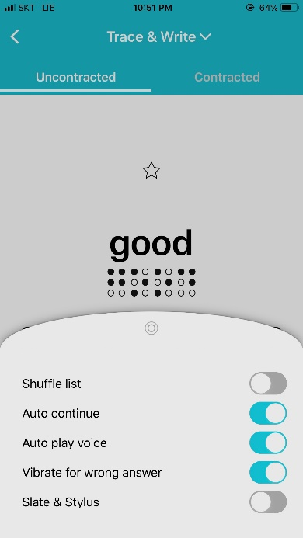

### 4.4.1 Shuffle list

The content from the list will be presented in a random order. Turn on or off by tapping on the toggle button. Default setting is off.

### 4.4.2 Auto continue

Once you are done with the current word, the app will automatically move to the next one. This setting is useful if you want the student to practice at their own pace, while being able to check their progress at them same time. Turn on or off by tapping on the toggle button. Default setting is on.

### 4.4.3 Auto play voice

When on, Taptilo will read the word or letter in the beginning as it displays in braille. When off, Taptilo will show in braille only without the audio. You can use the buttons on the screen to play the audio any time. This setting is useful for quizzing students. Turn on or off by tapping on the toggle button. Default setting is on.

### 4.4.5 Vibrate for wrong answer

When on, your phone or tablet will vibrate when there is a wrong answer. Turn on or off by tapping on the toggle button. Default setting is on.

### 4.4.6 Slate & Stylus

Change the braille writing style to Slate & Stylus. When turned off, you are using the Common writing style. Turn on or off by tapping on the toggle button. Default setting is off.

For more information on writing styles, see 2.4 Using the Braille Blocks.

## 4.5 Favorites

### 4.5.1 Adding or removing a favorite word

From the word screen, tap on the star button above the word to add to your favorites list (yellow star: added). Tap again to remove from your favorites list (white star: removed).

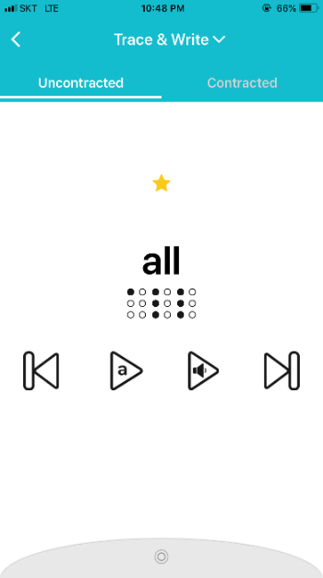 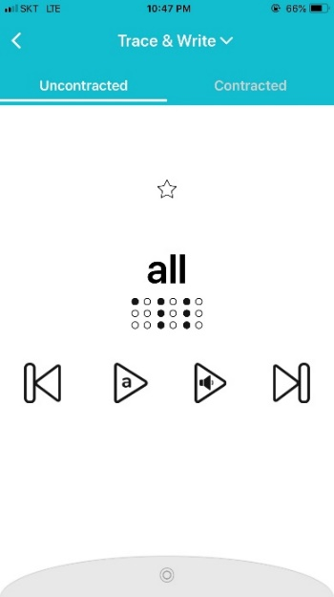

### 4.5.2 Managing Favorites List

1. From the app main screen, scroll down and select Favorites from the content list. The words will be shown in reverse order that they are added.
2. To remove a word from the favorites list, tap once on the yellow star on the upper right corner of each word card.

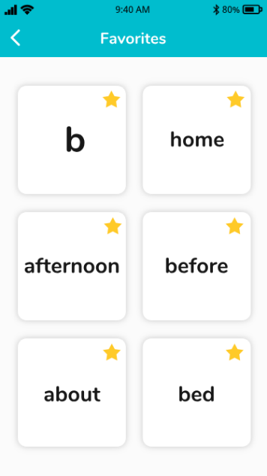

## 4.6 My Word List

### 4.6.1 Adding a new list

1. From the app main screen, scroll down and tap on the + sign or “Add a new list” button.
2. Enter the list name on the pop-up screen. Tap “save” to create the list. Word lists will be shown on the app main screen in the order they are created.

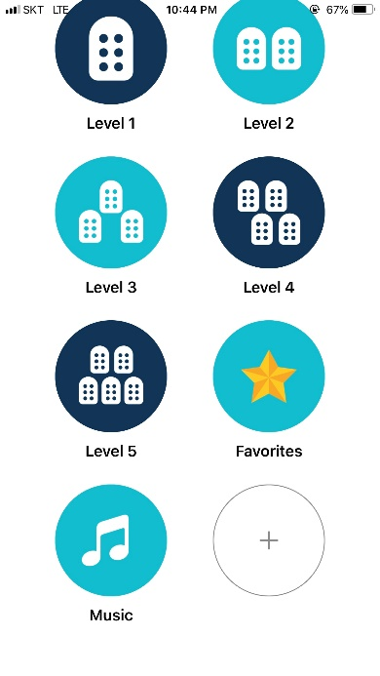 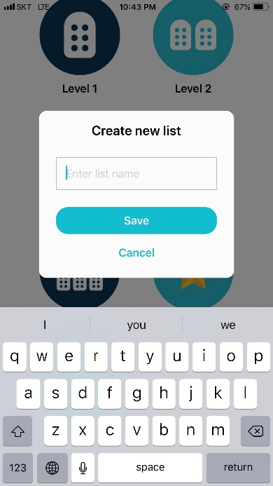

### 4.6.4 Adding words

1. From the list screen, tap the + sign or “Add a new word” button.
2. Enter a new word on the pop-up screen. Tap “Save” to create a new word card. The words will be shown in the order they are added.

**Note**:

* You can only add words for the current braille language you are using. (See 4.7.2 Language Settings)
* Added words can be seen in contracted braille only.
* Word limit is 9 characters. You cannot mix letters and numbers.

### 4.6.5 Deleting words

1. From the list screen, tap on the “Edit” button on the upper right corner to enter edit mode.
2. Tap on the X sign on the upper right corner of each word card. (For VoiceOver users: Each word card works as a delete button.)
3. When you are done editing, tap on the “Done” button on the upper right corner.

### 4.6.2 Editing list name

1. From the list screen, tap on the “Edit” button on the upper right corner to enter edit mode.
2. Tap on the list name on the top middle of the screen. Enter the new list name in the pop-up screen.
3. Tap “OK” to save.
4. Exit edit mode by tapping on the “Done” button on the upper right corner.

### 4.6.3 Deleting list

1. From the list screen, tap on the “Edit” button on the upper right corner to enter edit mode.
2. Tap on the trash bin icon or the “Delete list” button. From the pop-up, select “delete.”
3. Deleting a list will delete all the words in the list. Once deleted, there is no way to recover the list.

## 4.7 Managing Application Settings

To open application settings on the Taptilo+ app: From the main screen, tap on the “Options” button on the upper right corner, then tap “Settings.”

### 4.7.1 Bluetooth connection

**Connect your device**

1. Make sure Bluetooth is enabled on your smart device.
2. From the Settings menu, tap “Connect your device.”
3. From the pop-up screen, select your device serial number.
4. Once the device is paired, you will hear the audio, “application connected.” The device’s serial number will appear in blue under “Connected device.”
5. You can view the details of your device by selecting “Connected device”

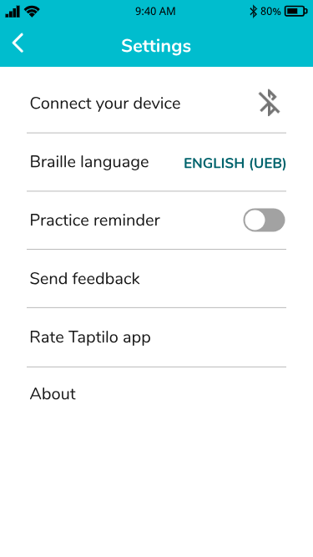 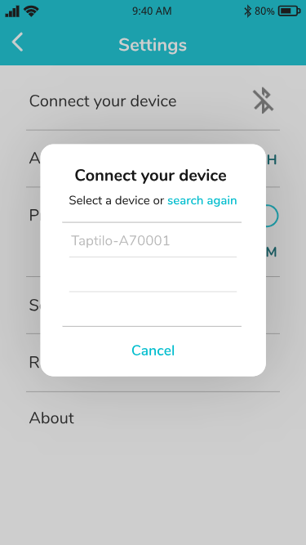 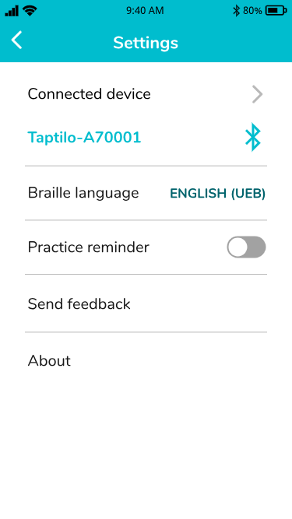

**Disconnect your device**

1. From the Settings menu, tap on the Bluetooth icon next to the device serial number, or select “Disconnect.”
2. From the pop-up screen, select “OK.”

### 4.7.2 Language settings

**Braille language**

Set the language of the braille learning content (in Teaching Mode). The device needs to be connected in order to use this setting.

1. After connecting with the device, choose from the menu and tap “OK.”
2. Exit Settings and go back to the main menu. You will be able to view the content in the selected language.

**Tip:** When the device is not connected, you can view all the languages that are available. Once device is connected, the list will show the languages that are available on your device.

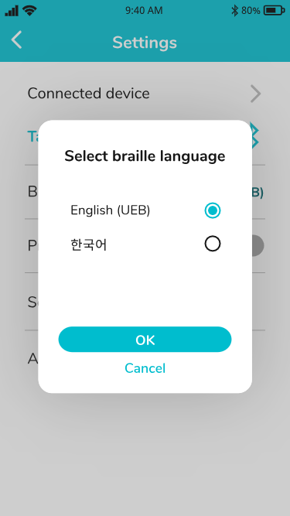

**App language**

Currently the app supports three languages, English, Korean and Arabic. The app language will follow the smart device’s language settings.

### 4.7.3 Practice Reminder

Set your daily practice reminder at the desired time. App notification should be enabled to use this feature.

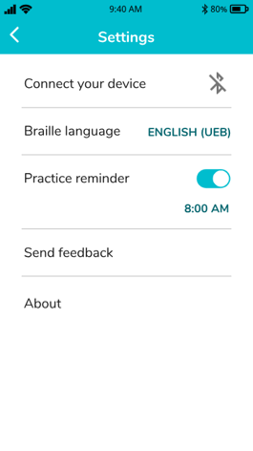

### 4.7.4 Send Feedback

Send feedback about the app to team. Directly connects to your email app.

### 4.7.5 About

View app version and license information.

# 5. Taptilo Music (Beta)

Learn basic music notes in braille. Please note that this is a beta version and does not include all music-related content.

## 5.1 Using Taptilo Music

### 5.1.1 Starting Taptilo Music

**From the device**

Go to Device settings > Program > Music. For more information, see 3.4 Device settings.

**From the app**

1. Connect Taptilo with the app (see 2.5 Pairing with the App).
2. From the app main screen, scroll down and select “Music.”
3. Select “Try it out” button and wait until Taptilo restarts to launch the music program. Once you hear the audio guidance, follow the instructions to use the program.
4. From the app, tap “OK” from the pop-up screen to disable the app. (Music is currently available for self-study only)

### 5.1.2 Ending Taptilo Music

**From the device**

Go to Device settings > Program > English. For more information, see 3.4 Device settings.

**From the app**

1. Reconnect Taptilo with the app.
2. From the music screen, tap on “End Taptilo Music.”
3. The device will restart to change to the braille program.

## 5.2 Music: Activities

### 5.2.1 Play a song

Learn music notes from the song, “Mary had a Little Lamb.

As in Trace & Write, read the notes on the braille display and use the blocks to create the same notes. Press the circle button to check the answer.

If you want to listen again, press the circle button for 2 seconds. To skip to the next line, press the right arrow button. To go straight to the last activity “Compose,” press both arrow buttons for two seconds.

### 5.2.2 Solfege

Learn the music notes that comprise a solfege, Do, Re, Mi, Fa, Sol, La, Ti and a high Do. All notes will be played in the fourth octave, and the last Do in the fifth octave.

The first part of this activity will introduce the notes in order. The second part will show the same notes mixed around.

As in Trace & Write, read the notes on the braille display and use the blocks to create the same notes. Press the circle button to check the answer.

### 5.2.3 Compose

Write your own tune using the blocks. Use the blocks to write any notes in braille. Press the circle button to play. (You need at least two notes written in order to play!)

Press the arrow buttons at any point during the activity to change the instrument. There are three instrument sounds available: piano, trumpet and bass. Press the circle button to play.

To return to the first activity, “Play a song,” press both arrow buttons for two seconds.